Name _______________________________ January 6, 2020
- Explain what a rational number is. Then, give at least 2 tips for placing a rational number on a number line correctly.
___________________________________________________________________________________________ _____________________________________________________________________________________________________________________________________________________________________________________________________________________________________________________________________________________________________________________________________________________________________________________________________________________________________________________________________________________________________________________________________________________________________________________________________________________________________________________________

- What is the opposite of the opposite of 17.5?

- Please plot -1.5 (T) and 2 ¼ (V) on the number line below:

-2
-1
1
2
0
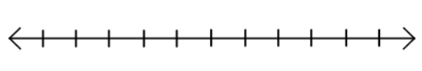

- In sixth grade, 27/60 kids ate hot lunch. What percent ate lunch from home?

- Complete the table:
Hours Worked | 1 | 5 | 10 | 40
Money Earned |  |  | $135

