Name _______________________________ January 7, 2020
- In the set of numbers {-1.75, -1, -2.5, -.1}, which is the greatest? Which is worth the least? Explain how you know, including where they would be located on a number line.
___________________________________________________________________________________________ _____________________________________________________________________________________________________________________________________________________________________________________________________________________________________________________________________________________________________________________________________________________________________________________________________________________________________________________________________________________________________________________________________________________________________________________________________________________________________________________________

- Order from least to greatest:
-99, -99.3, -100

- Please plot -2 ¼ (F) and ¾ (G) on the number line below:

-2
-1
1
2
0
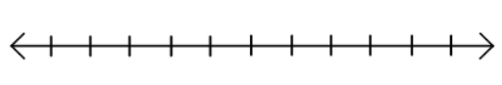

- Find the LCM and GCF of 24 and 36.

- I bought 15 apples for $7.20. What was the unit price?

