Name _______________________________ January 13, 2020
1. Explain what is meant by absolute value. Then, explain how to compare the absolute value of -10 and 9 and what your comparison means. (Please write in complete sentences and be ready to share in class.) ___________________________________________________________________________________________ _____________________________________________________________________________________________________________________________________________________________________________________________________________________________________________________________________________________________________________________________________________________________________________________________________________________________________________________________________________________________________________________________________________________________________________________________________________________________________________________________

- Complete with <, >, or =: -1.1 ______ -.8

- Please place .4, -3/5, -0.1 and 4/5 on the number line below and label them.

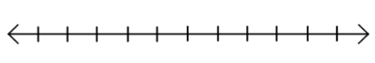

0
-1
1

- 75 is 30% of ________________.

- Joan bought apples to make pie at Smiths. She got 7.5 pounds for $6.60. After getting home, she realized she needed more apples and bought another 4.2 pounds from the Harmons near her home for $3.57. Which store sold apples at a cheaper price per pound?

