Name _______________________________ January 14, 2020
- Today, we investigated the absolute value of positive and negative rational numbers. What patterns emerged when we ordered the absolute values of negative numbers? What about the absolute values of positive numbers? Why do those patterns exist? Explain.
___________________________________________________________________________________________ _____________________________________________________________________________________________________________________________________________________________________________________________________________________________________________________________________________________________________________________________________________________________________________________________________________________________________________________________________________________________________________________________________________________________________________________________________________________________________________________________

- Use the set {-10, 6, -3, 0, 1} for a and b.
  - Order the numbers from least to greatest.

  - List the order of their absolute values from least to greatest.

- Please place 1/4, -3/4, -1.5 and 2.5 on the number line below and label them.

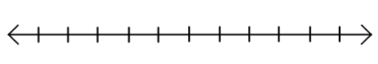

2
1
-1
-2
0

- Draw a model to show the quotient of 2/5 ÷ 3.

- The ratio of pepperoni to Hawaiian pizzas at the party is 4:1. If there were 18 more pepperoni pizzas than Hawaiian, how many pizzas were there at the party?

