Name _______________________________ March 2, 2020
- Summarize the problems we were working on today. Then, explain how these problems might be related to algebra.
___________________________________________________________________________________________ _____________________________________________________________________________________________________________________________________________________________________________________________________________________________________________________________________________________________________________________________________________________________________________________________________________________________________________________________________________________________________________________________________________________________________________________________________________________________________________________________

- If x + 13 is 30, what is x?

- Draw a rectangle whose perimeter is 20.

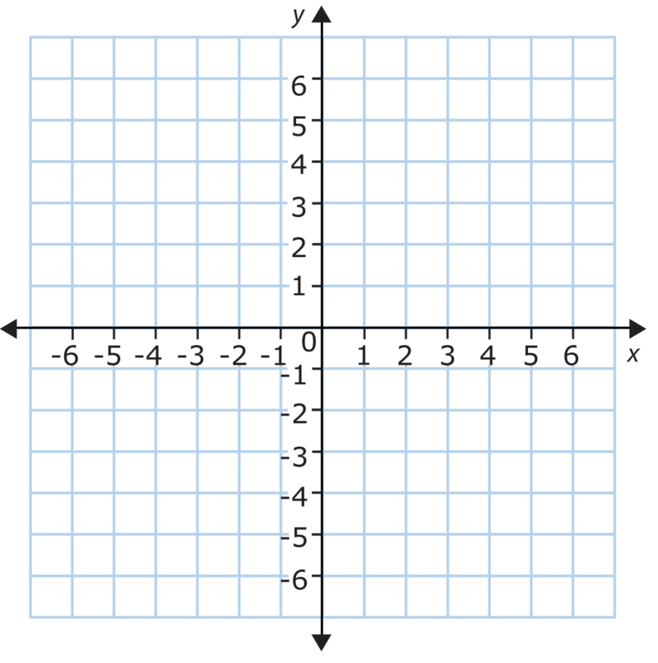

- Write an expression for the following situation. Then evaluate the expression for each value in the table below.
There are 3 cups of flour for every 1 cup of sugar in the recipe. Write an expression to find how many cups of flour when you have s sugar.

Expression: ____________________________

Sugar | Flour

- Put the following on a number line: -2.5, -2 1/3, -2.08

