Name _______________________________ March 3, 2020
- Today, you were introduced to some new mathematical symbols. What are they and what do they mean? Give an example of how to use them.
___________________________________________________________________________________________ _____________________________________________________________________________________________________________________________________________________________________________________________________________________________________________________________________________________________________________________________________________________________________________________________________________________________________________________________________________________________________________________________________________________________________________________________________________________________________________________________

- Tell which values for b would make the following inequality true: (The inequality is true when…)
10 + b > 42

- Find the perimeter of a rectangle which has vertices at (6, 6), (6, 2), (-2, 2), and (-2, 6).

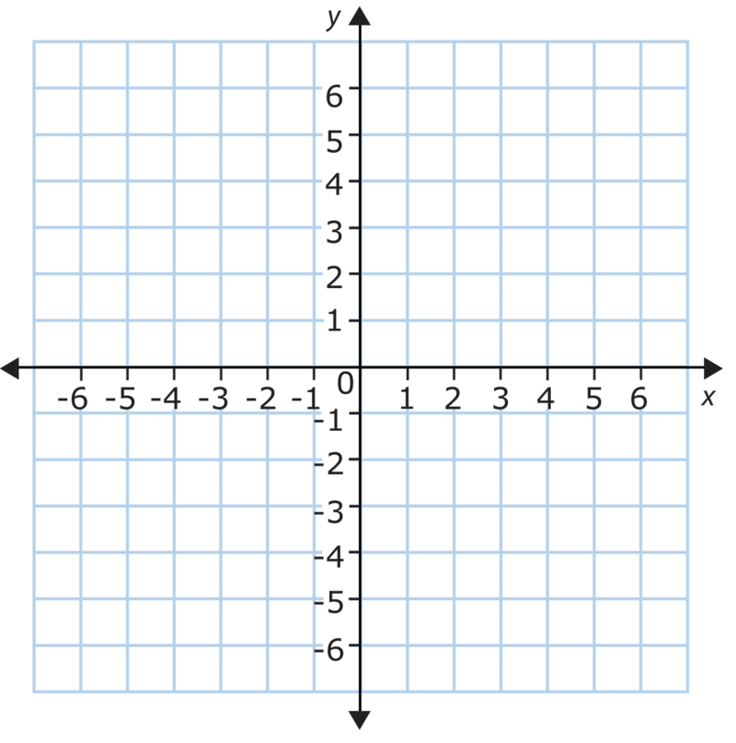

- How many ¾ size pieces are in 5?

- Evaluate the expression:

15.5 · 4 – 5.3 + 10

