Name _______________________________ March 4, 2019
- Today, you learned to solve addition and subtraction equations using models and algebraically. Which method do you prefer and why? Then, explain how the two methods are related.
___________________________________________________________________________________________ _____________________________________________________________________________________________________________________________________________________________________________________________________________________________________________________________________________________________________________________________________________________________________________________________________________________________________________________________________________________________________________________________________________________________________________________________________________________________________________________________

- Choose the statement that best describes the solutions to the inequality below:
m + 5 ≥ 12
- The inequality is true when m > 7.
- The inequality is true when m < 7.
- The inequality is true when m ≥ 7.
- The inequality is true when m ≤ 7.

- Draw a rectangle whose area is 24 square units.

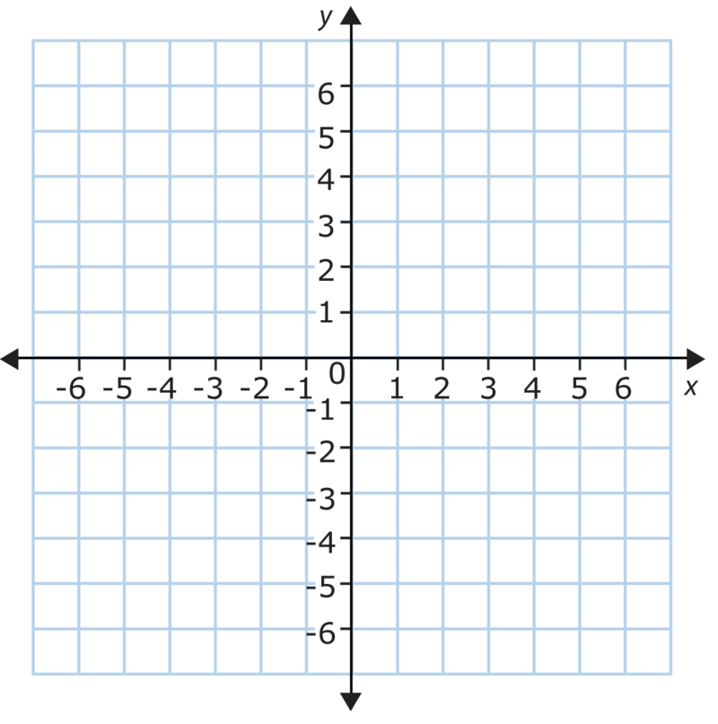

- Write an equation to represent the relationship in the table below.

Equation: ____________________________

Boxes of Donuts (b) | Total Donuts (t)
1 | 8
2 | 16
3 | 24
4 | 32
5 | 40
b | t = .

- Solve the equation algebraically or by using a model:

g – 62 = 14

