Name _______________________________ September 12, 2019
- This week, we’ve begun learning about ratios. What is a ratio? Write a definition that makes sense to you. Then, explain why someone who runs a T-Shirt store (as in today’s lesson) would want to use ratios. (Your response to the question should be very detailed! Please write in complete sentences and be ready to share in class.) _______________________________________________________________________________________________________________________________________________________________________________________________________________________________________________________________________________________________________________________________________________________________________________________________________________________________________________________________________________________________________________________________________________________________________________________________________________________________________________________________________________________________________________________________________________________________________________________________________________________________________________________________________________________

- Find the LCM of 15 and 25.
- Find the GCF of 56 and 70.

- In every treat bag, there were 6 candies, 2 bouncy balls, and a pencil. Describe the ratio relationship between the number of bouncy balls and the number of candies using ratio language. (For every… there are…)

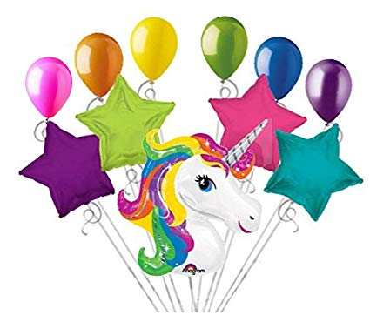
- Write 3 ratios that describe the balloon bouquet below:

