Name _______________________________ September 24, 2019
- On the table below, show some of the patterns that exist on ratio tables that we discussed in class today. Then, write about the one that you use most often when completing or correcting a ratio table. (Your response to the question should be very detailed! Please write in complete sentences and be ready to share in class.)
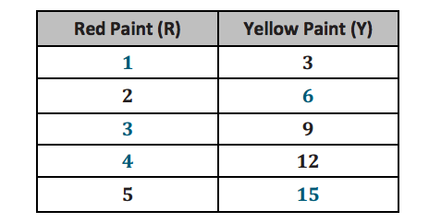
________________________________________________________________________________________________________ ________________________________________________________________________________________________________________________________________________________________________________________________________________________________________________________________________________________________________________________
- Find the LCM of 21 and 35.

- The exercise video includes sets of 5 jumping jacks followed by 4 burpees. Write the ratio of the number of burpees to the number of jumping jacks.

- Are 6:15 and 8:20 equivalent? Show how you know.

- For every 5 people that like chocolate sauce on their ice cream sundaes, there are 2 that prefer caramel sauce. If there are 18 more people that prefer chocolate sauce, how many people prefer caramel sauce?

