Name _______________________________ December 16, 2019
- We use negative numbers frequently in real-world situations. Give an example of a real situation in which you’d use negative numbers. Then, give at least one word in that situation that would indicate a positive integer and a word that would indicate a negative one.
___________________________________________________________________________________________ ____________________________________________________________________________________________________________________________________________________________________________________________________________________________________________________________________________________________________________________________________________________________________________
_________________________________________________________________________________________________________________________________________________________________________________________________________________________________________________________________________________

- For each, write the integer that represents the situation:

  - I deposited $200 into my account.

  - The bank charged a fee of $25 for the late payment.

Yards | 1 | 2 | 3 | 4
Inches
- Please plot -2 (M) and 4 (P) on the number line below:

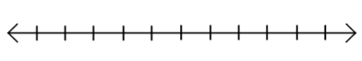

- Find the difference of 13.5 and 11.37.

- Complete the table of equivalent ratios:

