Name _______________________________ December 17, 2019
- Today, we worked with situations involving elevation. What is elevation and how is it connected with negative integers? After explaining, give a real world situation that deals with elevation and includes a negative and a positive integer.
___________________________________________________________________________________________ ____________________________________________________________________________________________________________________________________________________________________________________________________________________________________________________________________________________________________________________________________________________________________________
_________________________________________________________________________________________________________________________________________________________________________________________________________________________________________________________________________________

- For each, write the integer that represents the situation:

  - The submarine went to a depth of 60 meters.

  - It was 7 degrees below zero.

- Please plot -8 (A) and 10 (B) on the number line below:

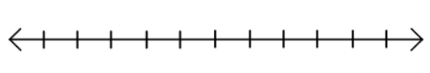
Hours | 1 | 2 | 3 | 8
Inches of Snowfall |  | 3

- Find the quotient of 537.3 and 2.1.

- Complete the table of equivalent ratios:

