Name _______________________________ December 19, 2019
- Today, we learned about opposite integers and the “opposite of the opposite”. Explain those two concepts. Use number lines to support your explanation.
___________________________________________________________________________________________ ____________________________________________________________________________________________________________________________________________________________________________________________________________________________________________________________________________________________________________________________________________________________________________

- What is the opposite of -25? How do you know?

- Please plot -6 (T) and 7 (V) on the number line below:

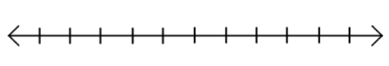

- Anita is making bags of popcorn for the bake sale. She wants to make 20 equal bags. If she has 8 ¾ pounds of popcorn, how many pounds will go in each bag?

Blue Marbles | 3 | 12 | 15 | 21
Green Marbles |  | 8

- Complete the table of equivalent ratios:

